Brake Light Circuit Board

GT Off-Road Racing | Data Acquisitions

Ryan Chen

6/6/2020

Table of Contents

1.0 Overview/Function 2

2.0 Hardware Reference 3

2.1 Power Block 3

2.2 Input Signals Block 3

2.3 Voltage Comparator Block 4

2.4 Arduino Signal Block 5

# 1.0 Overview/Function

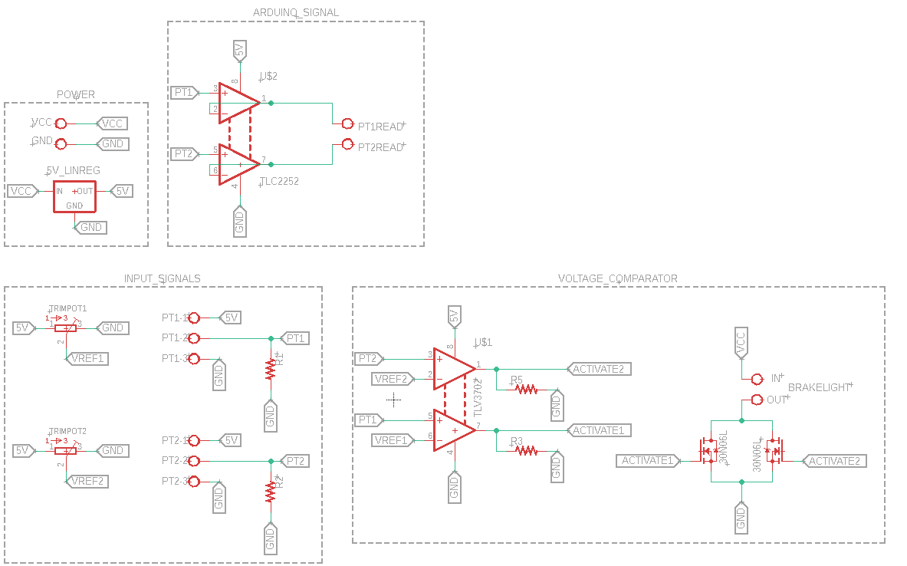

This circuit board turns off the brake light of the vehicle when the brakes are pressed. Using two pressure transducers to sense the pressure applied to the brakes. Two pressure transducers are used so that in case one pressure transducer fails, the other will act as a backup.

# 2.0 Hardware Reference

## 2.1 Power Block

The circuit board receives power from an 11V lithium ion battery, with the positive side connected to VCC, and the negative side connected to GND. A 5V linear voltage regulator is used to convert the 11V from the battery into 5V, which is the primary voltage used by the majority of the circuit.

## 2.2 Input Signals Block

The Input Signals Block deals with voltages that will be used in the hardware logic to turn on the brake light. This block introduces the following voltages:

|  |  |
| --- | --- |
| VREF1 | Voltage threshold at which pressure transducer 1 will turn on. |
| VREF2 | Voltage threshold at which pressure transducer 2 will turn on. |
| PT1 | The voltage received from pressure transducer 1. |
| PT2 | The voltage received from pressure transducer 2. |

The variable resistance of TRIMPOT1 (potentiometer) will be adjusted to tune VREF1, so that the brake light turns on when the brake is ever so slightly pressed. The component PT1, is a 3-input screw terminal, PT1-2 is the output voltage of the pressure transducer 1. R1 is a pull-down resistor.

The logic for TRIMPOT2, PT2, etc., are the same as the logic for TRIMPOT1, PT1, etc. Line 2 acts as a backup so that the brake light circuit board will function correctly even if Line 1 malfunctions

## 2.3 Voltage Comparator Block

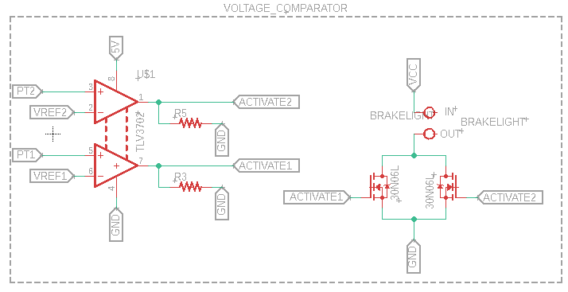

The Voltage Comparator Block compares the voltages from the Input Signals Block to turn on the brake light.

A TLV3072 (2-element rail-to-rail linear voltage comparator) compares each pressure transducer’s PT voltage with its respective VREF voltage. If the PT voltage is greater than the VREF voltage, then the ACTIVATE voltage will be high, allowing current to flow through the 30N06L (N-channel MOSFET). This will in turn cause the brake light to turn on.

The dual 30N06L MOSFET setup acts as an OR-gate, so that if one line malfunctions. R5 and R3 are pull-down resistors.

## 2.4 Arduino Signal Block

The Arduino Signal Block allows an optional connection to 2 Arduino pins so that the voltage from the pressure transducers can be read by the Arduino.

A TLC2252 (2-element rail-to-rail op-amp) is used as a voltage follower, so that the Arduino is isolated and does not interfere with the rest of the circuit.

## 